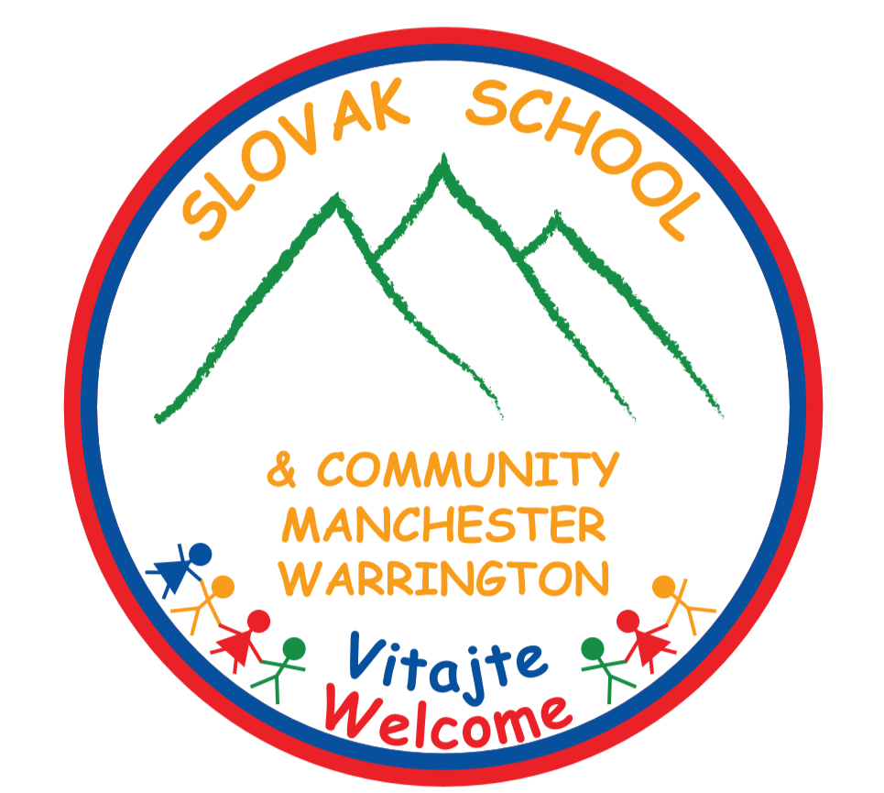 Dates and fees 2020-21
Autumn term ( 5.9., 12.9., 19.9., 26.9., 3.10., 10.10., 17.10., 31.10.) 8 sessions, price includes 1 free session
Manchester classes Warrington classes
Motýliky (predškoláci) £50 per term Lienky £60 per term
Trieda 6+ £60 per term Motýliky £60 per term
Trieda 8+ £60 per term Sovičky £60 per term
Slovak for adults £60 per term Slovak for adults £60 per term
Winter term ( 7.11., 14.11., 21.11., 28.11., 5.12., 12.12. 2020, 9.1., 16.1., 23.1., 30.1. 2021) 10 sessions, price includes 1 free session and a school event
Manchester classes Warrington classes
Motýliky (predškoláci) £75 per term Lienky £95 per term
Trieda 6+ £95 per term Motýliky £95 per term
Trieda 8+ £95 per term Sovičky £95 per term
Slovak for adults £95 per term Slovak for adults £95 per term
Spring term ( 6.2., 13.2., 27.2., 6.3., 13.3., 20.3., 27.3., 17.4., 24.4.) 9 sessions, price includes 1 free session
Manchester classes Warrington classes
Motýliky (predškoláci) £75 per term Lienky £90 per term
Trieda 6+ £90 per term Motýliky £90 per term
Trieda 8+ £90 per term Sovičky £90 per term
Slovak for adults £90 per term Slovak for adults £90 per term
Summer term ( 1.5., 8.5., 15.5., 22.5., 29.5., 12.6., 19.6., 26.6., 3.7., 10.7.) 10 sessions, price includes 1 free session, Open day and a school trip
Manchester classes Warrington classes
Motýliky (predškoláci) £75 per term Lienky £90 per term
Trieda 6+ £90 per term Motýliky £90 per term
Trieda 8+ £90 per term Sovičky £90 per term
Slovak for adults £90 per term Slovak for adults £90 per term
Session lasts 10:00 – 12:45 (3 x 45 mins lessons).
Single session payments only in specific cases and these are:
£10 per session Motýliky (predškoláci), £12 per session other classes.
Slovak one-to-one £15 per lesson (to be arranged individually).
English as foreign language available, contact us for more details.
Online classes also available.
Toddler playgroup will be open in case of interest.
Bank details: Lloyds TSB Registered Charity no: 1185004
Account no: 49504068 https://www.slovakschoolmanchester.org.uk/
Sort code: 30-90-89 Find us on Facebook & Instagram

OUR ADDRESS:

MANCHESTER:
Manchester Communication Academy
2 Silchester Drive,
M40 8NT
Manchester
England
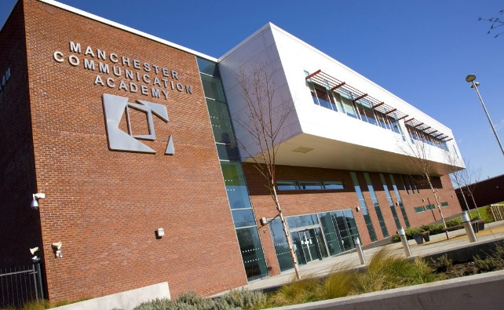

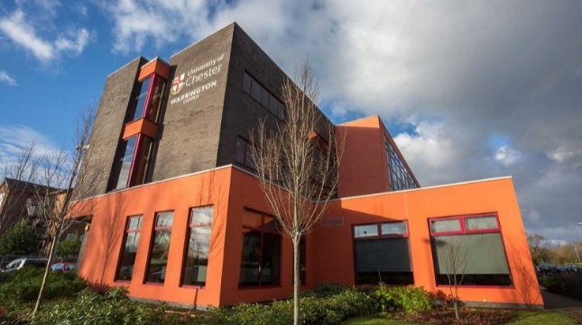
WARRINGTON:
University of Chester,
Warrington Campus,
Crab Lane,
WA2 0DB
Warrington
England

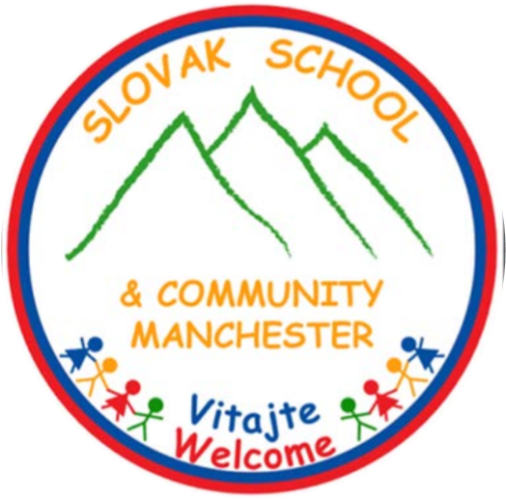

Registered Charity no. 1185004
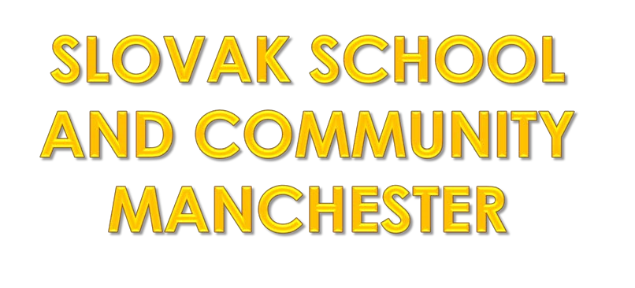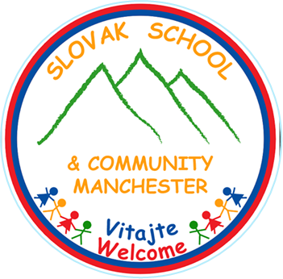
- Charitable Organization providing Saturday language lessons for Slovak and Slovak-English children aged 12 months to 13 years and also adults, organizing community activities and assists with expats advise
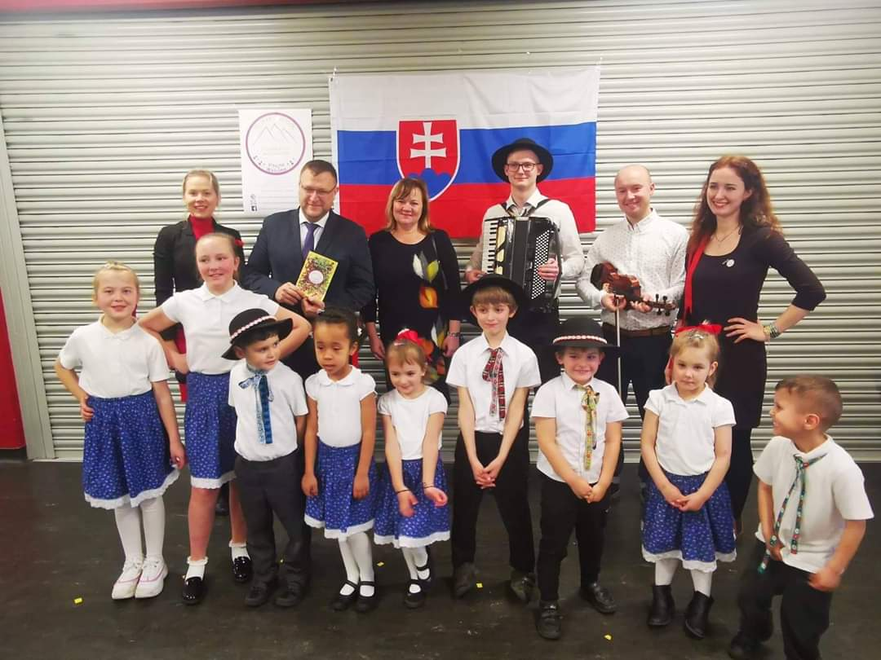
- Education is provided by qualified teachers and led by volunteers and charity trustees
- School organizes social and recreational events, whilst promoting our language, traditions and culture

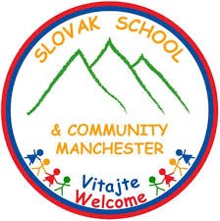
OUR CLASSES

SLOVAK PLAYGROUP 0-3 YEARS OLD-

- Kids spend time in stimulating atmosphere with qualified teacher

- Play games, draw, paint, learn nursery rhymes and songs

SLOVAK PRESCHOOL 3-5 YEARS OLD-

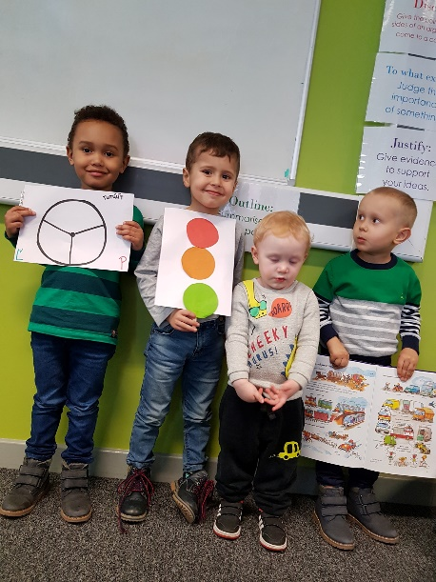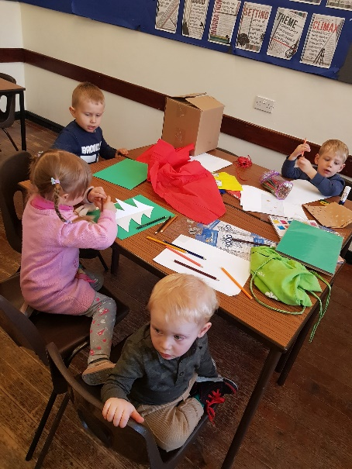

- Kids here improve their Slovak communication abilities by means of disscusions, various games, exercises and other communications-focused activities

SLOVAK SCHOOL CLASS 5+

- For fluent Slovak speaking children aged 5-13 years old
- We support children to be confident in listening, speaking, reading and writing competences playfully and focus on basic of grammar

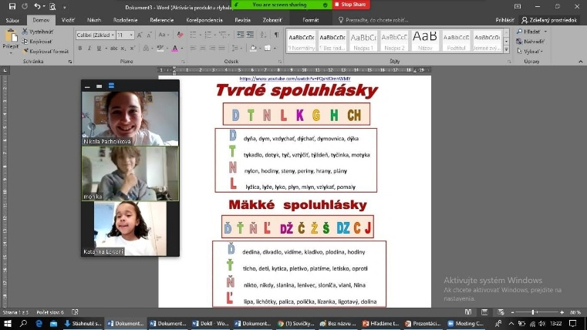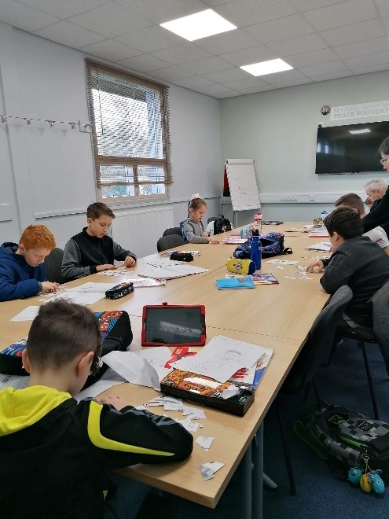

SLOVAK SCHOOL AS FOREIGN LANGUAGE 6 + ADULTS

- Slovak language class for kids and adults

- For beginners in Slovak language

- Focus on communication and conversation, everyday language, basics of grammar , necessary vocabulary

- Entartaining way of learning

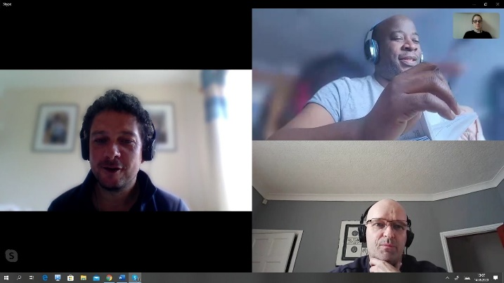

ADDITIONAL DEATAILS
SESSION STARTS: 10:00 – 12:45
Contact:
E: slovakschoolmanchester@gmail.com
warrington.sscm@gmail.com

WEB SITE: Slovak School & Community Manchester
FACEBOOK: slovak school and community manchester

